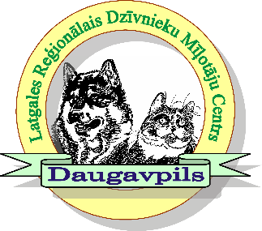

Latgales reģionālais Dzīvnieku mīļotāju centrs
Show place : Višķu stadiona un estrādes komplekss
( višķu tehnikums, Višķu pagasts, LV-5481) / GSP : 56.062742; 26.770474
- ​25.06.2022 / National Dog Show “Summer in Latgale ”
- 26.06.2022 / National Dog Show ”Blue Lake Land Cup ””

GUARANTEE LETTER

I _______________________________________________________, place of residence
(legible full name, surname, passport No)
_________________________________________________________________________
(legible full address, phone, e-mail)

undertake to pay the registration fee for my dog(s) in full at the entrance to Daugavpils National Dog shows / Latgales Regional club , or partly in the cases specified in the Latvian Cynological Federation Regulations for dog shows (dog’s death or illness etc., which should be confirmed by a veterinarian’s statement), in the amount of ___________ EUR, regardless of any circumstances. The payment is guaranteed even in the case of not coming to the dog show.

Nr. | Breed | Dog name | Pedigree number | EUR
1
Kopā:

_________________________________________________________
(Date , signature )

